TITANIC DATA ANALYSIS USING PYTHON

Internship Project Report

Submitted By:
Name: D.Sameaswar

College: JAIN UNIVERSITY

Internship Organization: RD INFRO TECHNOLOGY

Project Title: Titanic Data Analysis using Python

Submission Date: 29/06/2026

Table of Contents

Introduction

Objective

Software Requirements

Dataset Description

Methodology

Task 1 – Data Collection

Task 2 – Data Cleaning

Task 3 – Data Transformation

Task 4 – Exploratory Data Analysis

Task 5 – Statistical Analysis

Task 6 – Predictive Modeling

Task 7 – Dashboard Creation

Results

Conclusion

References

1. Introduction

Data analysis is the process of collecting, cleaning, transforming, analyzing, and visualizing data to discover meaningful insights. In this project, the Titanic dataset is analyzed using Python, machine learning, and Power BI to understand passenger survival patterns and build a predictive model.

2. Objective

The objectives of this project are:

Collect the Titanic dataset.

Clean missing and inconsistent data.

Transform data for better analysis.

Perform Exploratory Data Analysis (EDA).

Conduct Statistical Analysis.

Build a Logistic Regression model.

Create an interactive Power BI dashboard.

3. Software Requirements

Python 3.x

Visual Studio Code

Power BI Desktop

Python Libraries

Pandas

Matplotlib

Scikit-learn

4. Dataset Description

The Titanic dataset contains information about passengers aboard the RMS Titanic.

The dataset contains 891 records and includes the following columns:

PassengerId

Survived

Pclass

Name

Sex

Age

SibSp

Parch

Ticket

Fare

Cabin

Embarked

5. Methodology

The project follows the Data Analytics lifecycle:

Data Collection

Data Cleaning

Data Transformation

Exploratory Data Analysis

Statistical Analysis

Predictive Modeling

Dashboard Creation

6. Task 1 – Data Collection

The Titanic dataset was loaded using the Pandas library. The CSV file was imported into Python for analysis.

Dataset Used:

titanic.csv

7. Task 2 – Data Cleaning

The following cleaning operations were performed:

Filled missing Age values using the median.

Filled missing Embarked values using the mode.

Removed the Cabin column due to excessive missing values.

Saved the cleaned dataset as titanic_cleaned.csv.

8. Task 3 – Data Transformation

The following transformations were applied:

Created FamilySize column.

Created IsAlone column.

Converted Sex into numerical values.

Converted Embarked into numerical values.

Saved the transformed dataset as titanic_transformed.csv.

9. Task 4 – Exploratory Data Analysis

EDA was performed using Matplotlib.

Visualizations created:

Survival Count

Age Distribution

Fare Distribution

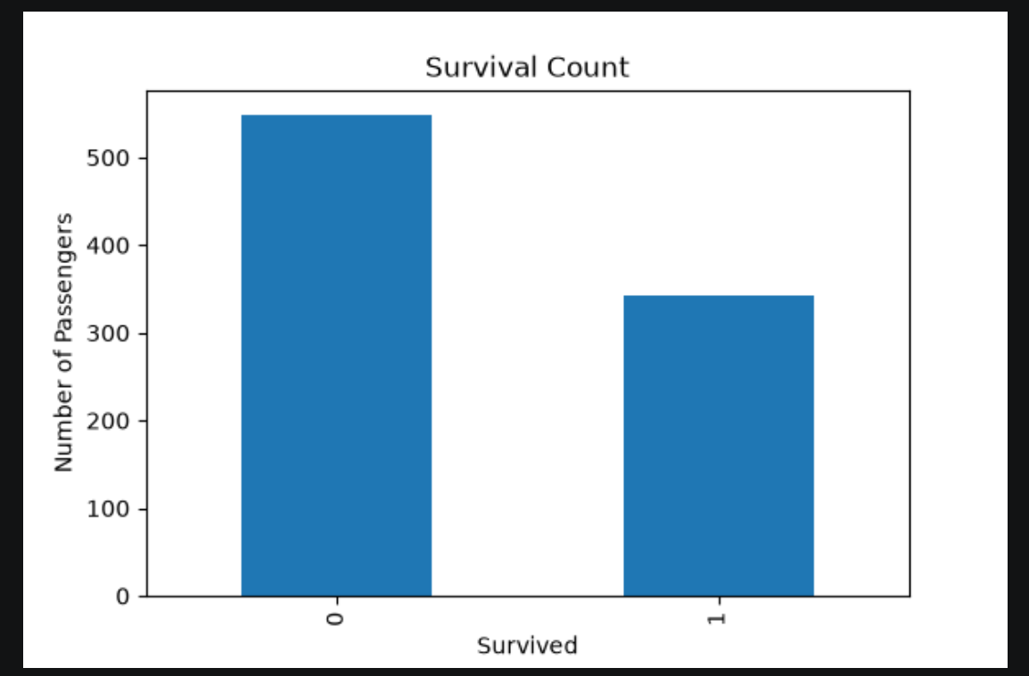

survival_count.png

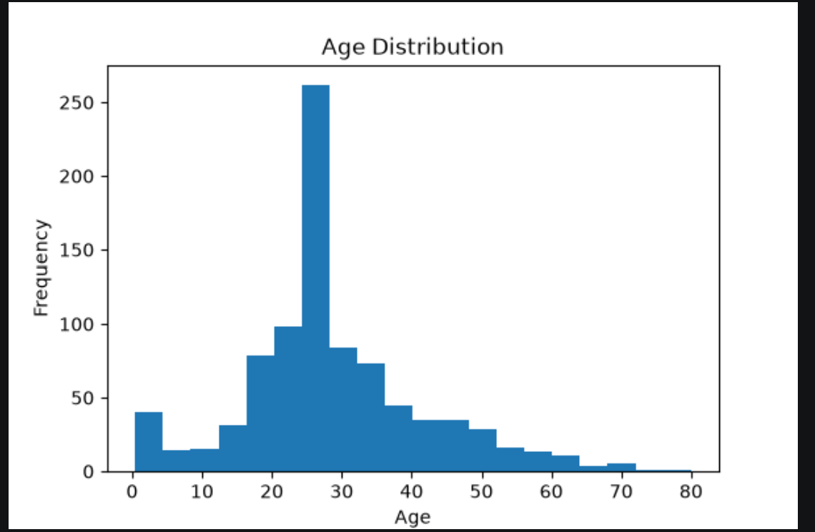
- age_distribution.png

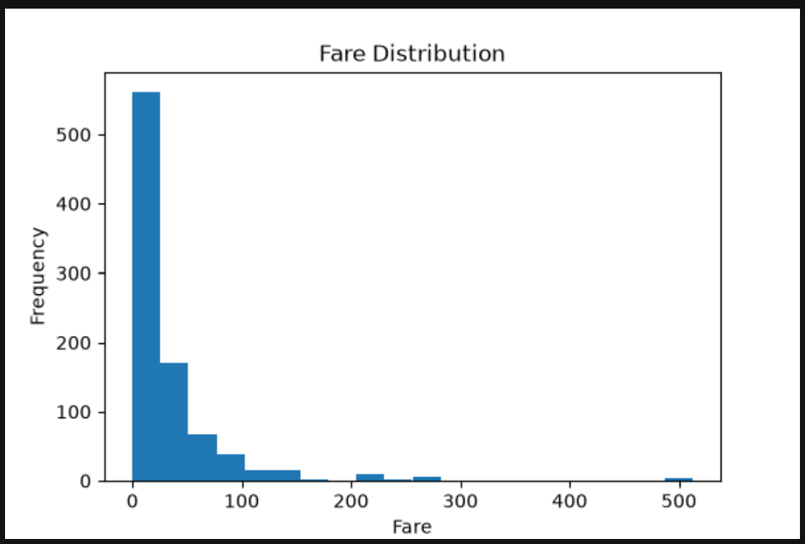
- fare_distribution.png

10. Task 5 – Statistical Analysis

The following statistical measures were calculated:

Mean

Median

Mode

Standard Deviation

Variance

Correlation Matrix

These measures helped understand the dataset and relationships between variables.

11. Task 6 – Predictive Modeling

A Logistic Regression model was developed to predict passenger survival.

Input Features:

Passenger Class

Sex

Age

Fare

Family Size

IsAlone

Model Accuracy:

79.89%

A confusion matrix was generated to evaluate model performance.

12. Task 7 – Dashboard Creation

An interactive dashboard was developed using Power BI.

Dashboard Components:

Total Passenger Card

Survival Pie Chart

Survival by Gender

Age Distribution

Gender Slicer

Passenger Class Slicer

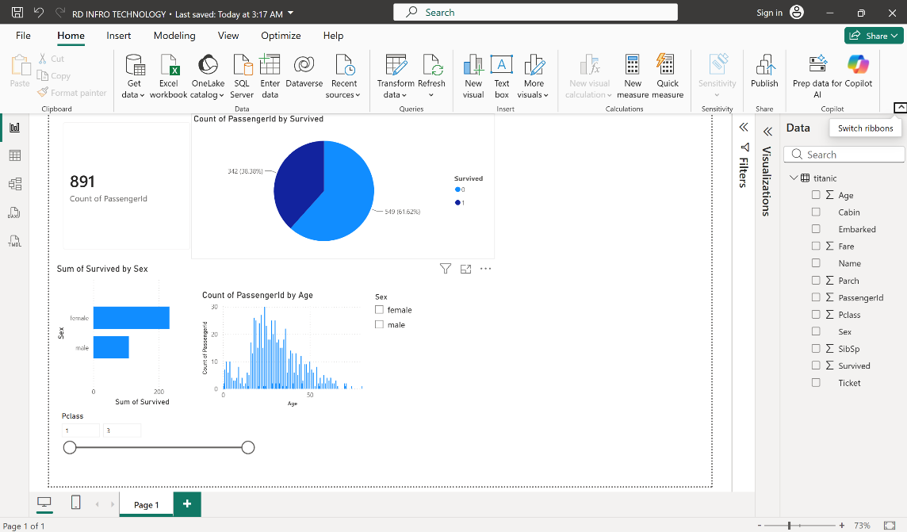

13. Results

The Titanic dataset was successfully analyzed.

Key outcomes:

Missing values were handled successfully.

Data transformation improved analysis.

Statistical analysis provided insights into passenger data.

Logistic Regression achieved approximately 80% prediction accuracy.

Interactive Power BI dashboard enabled visual exploration of the dataset.

14. Conclusion

This project successfully demonstrated the complete data analysis process using Python and Power BI. Data was collected, cleaned, transformed, analyzed, and visualized. A predictive model was built with good accuracy, and an interactive dashboard was created to summarize key insights.

This project enhanced practical knowledge of Python programming, data analytics, machine learning, and business intelligence.

15. References

Kaggle Titanic Dataset

Pandas Documentation

Matplotlib Documentation

Scikit-learn Documentation

Microsoft Power BI Documentation

